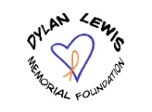

The Dylan Lewis Memorial Foundation is pleased to

announce two scholarship opportunities for 2025 Ida High

School graduating seniors:

The DLMF $500 scholarship and

The Sweets Strong $500 scholarship

To apply, please submit an essay answering the following

question- How will you use your career to

positively impact others?

Applications are due by March 21, 2025. Turn in

applications to the Ida High School office to Mrs. Ryan.