IDA MIDDLE SCHOOL MORNING ANNOUNCEMENTS
Wednesday, April 24, 2024
Good morning, BLUESTREAKS!

*7/8th graders the Spring Dance will be Friday, April 26th from 7-10pm. Please don’t arrive before 7 and have a planned ride home by 10pm. Cost is $5 at the door, concessions are extra. No outside guests are allowed, this is a dance for Ida Middle School students only and you must be in attendance that day to attend (or have it pre-arranged with the office). This is a dress up dance, but please keep the dress code in mind when purchasing an outfit.

**The Class of 2026 is planning the annual Cedar Point trip for students in the 7th through 11th grades, on June 12th. The cost of this trip is $90, tickets will be sold in the MS office beginning on April 29th and running through May 17th. There is a flyer here in the office with more information if you’d like one.

**Theme 9: Lounge
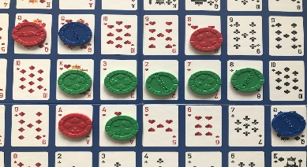
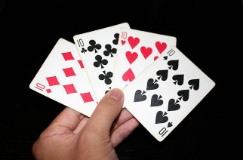

Date: Thursday, April 25th
Location: Mrs. Ashcraft’s Classroom (room 5)
Time: 3:15-4:15
What: Listen to music and play games

*Oh, friends…I have the Earth Day Pride Point results for you! Facebook land has spoken and taking home all the points for the month of April is the 6th grade!
2nd place was the 8th grade
3rd place goes to the 5th grade
And rounding us out in 4th place is the 7th grade.

Overall PRIDE points are as follows:
In 4th place with 24 points is the 7th grade
Making gains, but still in 3rd place is the 8th grade with 42 points
In 2nd place is the 6th grade who also made up two points for a total of 46
And hanging on to 1st place is the 5th grade with 48 points…

MS BAND:
MS Choir:
FFA News:
MS Sports News:
MS Track:

MS Student Council:
**The 8th grade student council members will be called down at the very end of 4th hour to start decorating the cafeteria for the dance this Friday.

Also, the School Improvement Committee will be gathering trash next Monday, April 29th at 2pm for their “Adopt A Road” program.”

**Remember, it’s a GREAT DAY to be a BLUESTREAK! At this time, please stand with your class to recite the Pledge of Allegiance.

